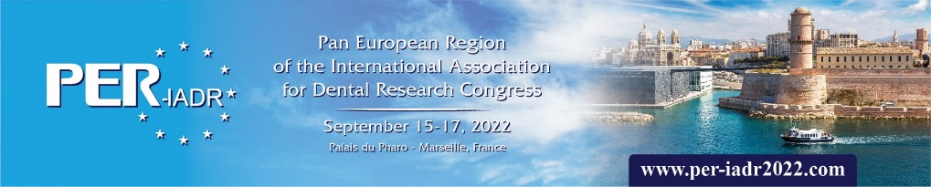
SYMPOSIUM PROPOSAL FORM
Please return this form ASAP to ced.iadr@uzleuven.be
PREFERRED DATE & TIME SLOT:  ( Time slot will be assigned according to availability of the slot, the ‘first-come, first-served’ principle, and sponsor level ) | AVAILABLE TIME SLOTS FOR THE MEETING:  Date: Morning: Afternoon:  Thursday, September 15, 2022 10:30-12:30hr 13:30-15:30hr  Friday, September 16, 2022 10:30-12:30hr 13:30-15:30hr  Saturday, September 17, 2022 10:30-12:30hr n/a  Please indicate 3 time slots in order of preference:  - …  - …  - …
SYMPOSIUM COORDINATOR: | Please appoint a neutral person (not affiliated to the sponsoring company) who must ensure that the symposium proposal is completed in accordance with the symposium regulations. The symposium coordinator acts as an intermediary between the sponsoring company and the CED/PER-IADR Board.  Name:  Affiliation:  Email:  Telephone number:
CONTACT PERSON OF THE SPONSORING COMPANY:
PROPOSED SYMPOSIUM TITLE:

 | PROPOSED SPEAKER | SPEAKER AFFILIATION & CONTACT DETAILS (Email & Tel) | PROPOSED LECTURE TITLE  Three 35 min. lectures + 15 min. discussion time is recommended. | DURATION
1
2
3
 | PROPOSED CHAIR PERSON (at least one) | CHAIR AFFILIATION & CONTACT DETAILS (Email & Tel)
1
2
CONSULT THE INDUSTRY-SPONSORED SYMPOSIUM AND EXHIBITION REGULATIONS.

